**PROPERTIES**

* In *Properties* you can assign interface and package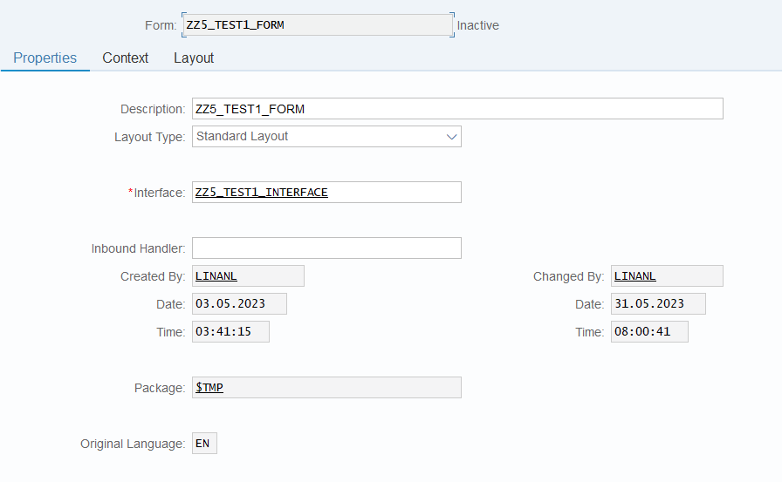

**CONTEXT**

* In *Context* you can pass the get the value from interface/drivers program and use it in form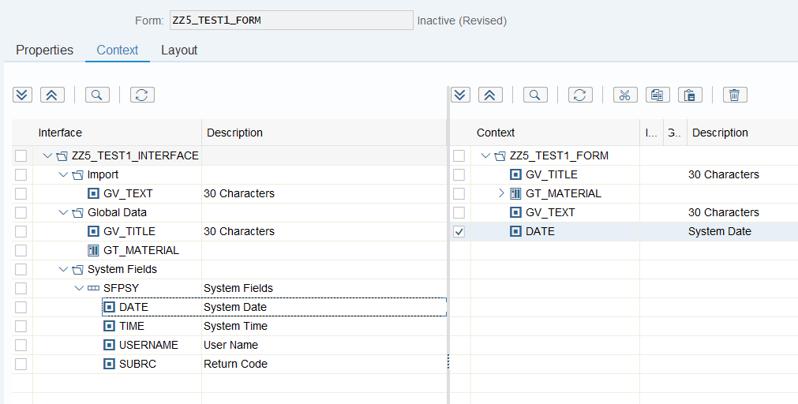

**LAYOUT**

* In *Layout* you can maintain the view of the form using values

